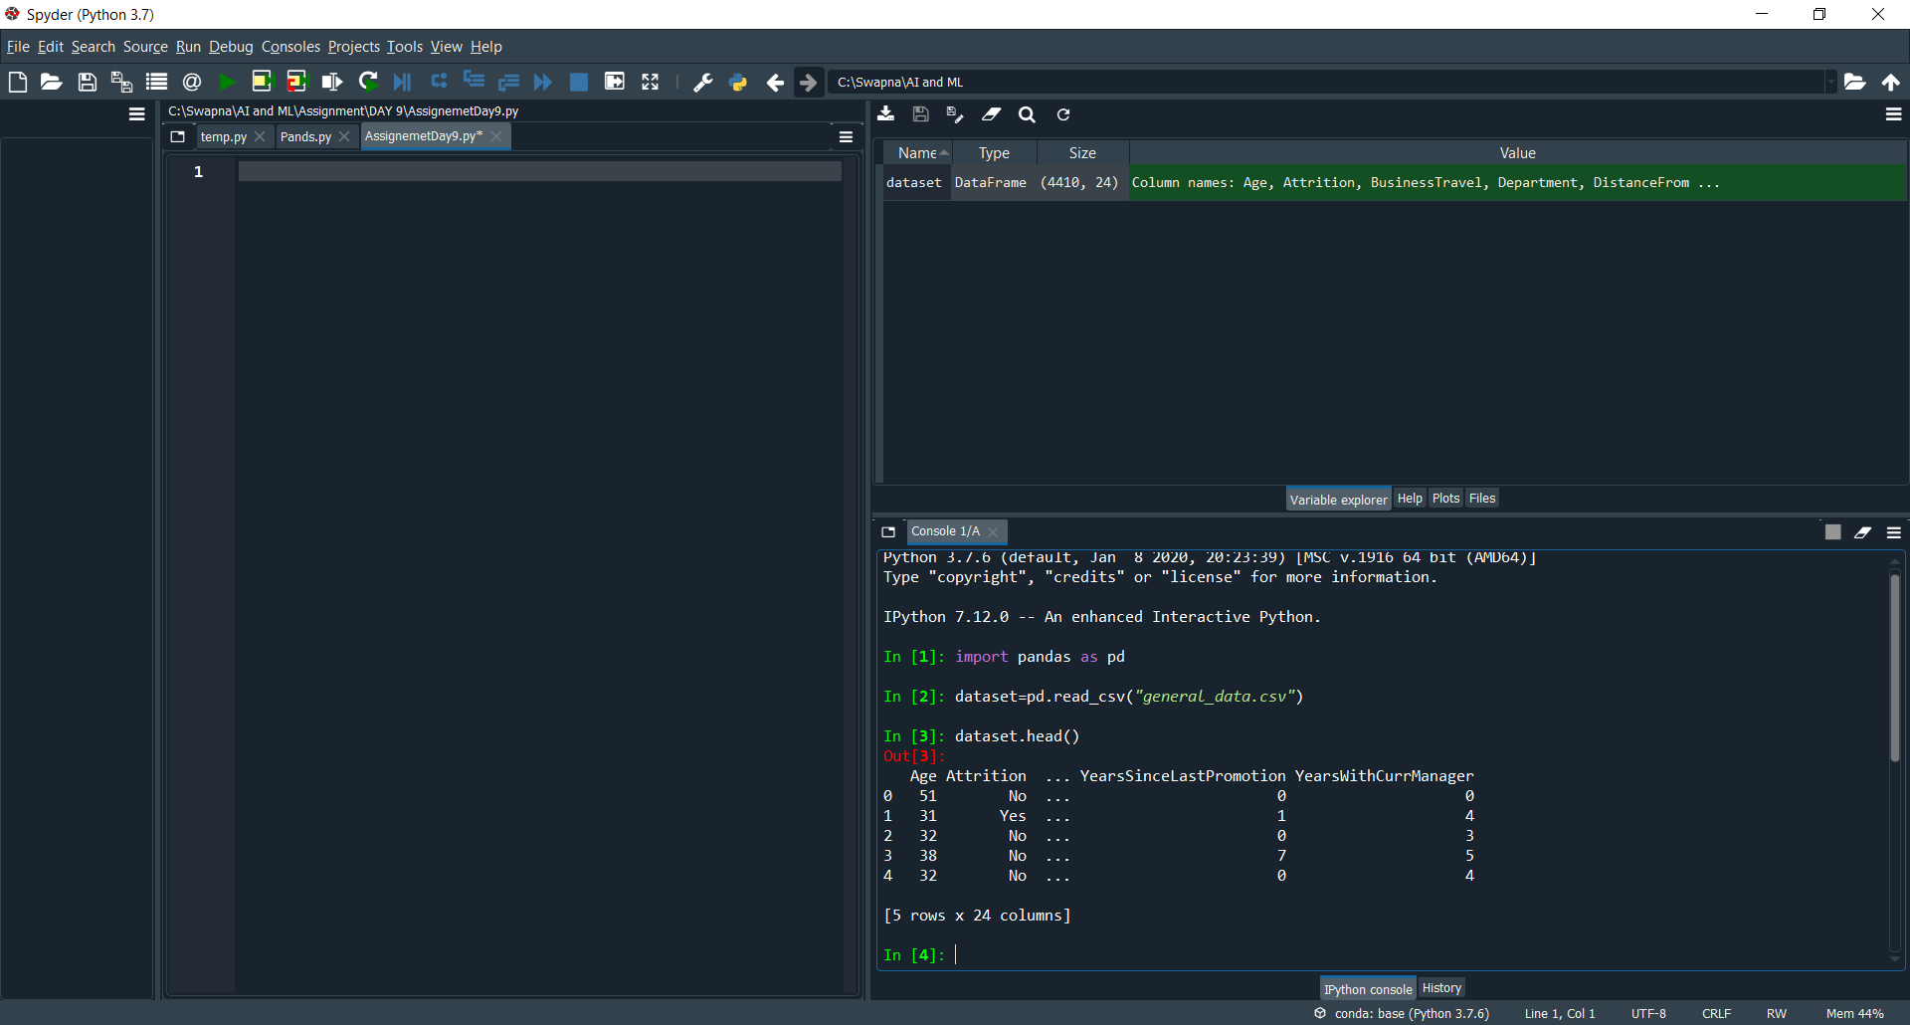

dataset.head()

by this we can see the first 5 records in the data sheet.

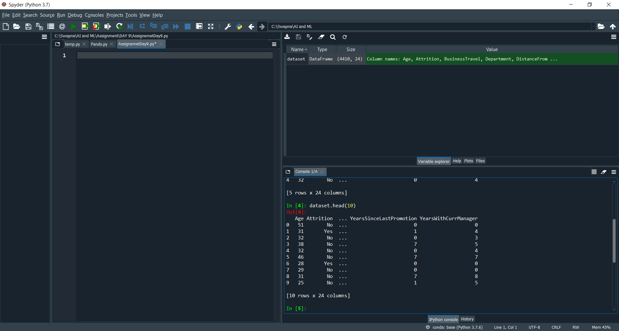

dataset.head(10)

it will prints first 10 records

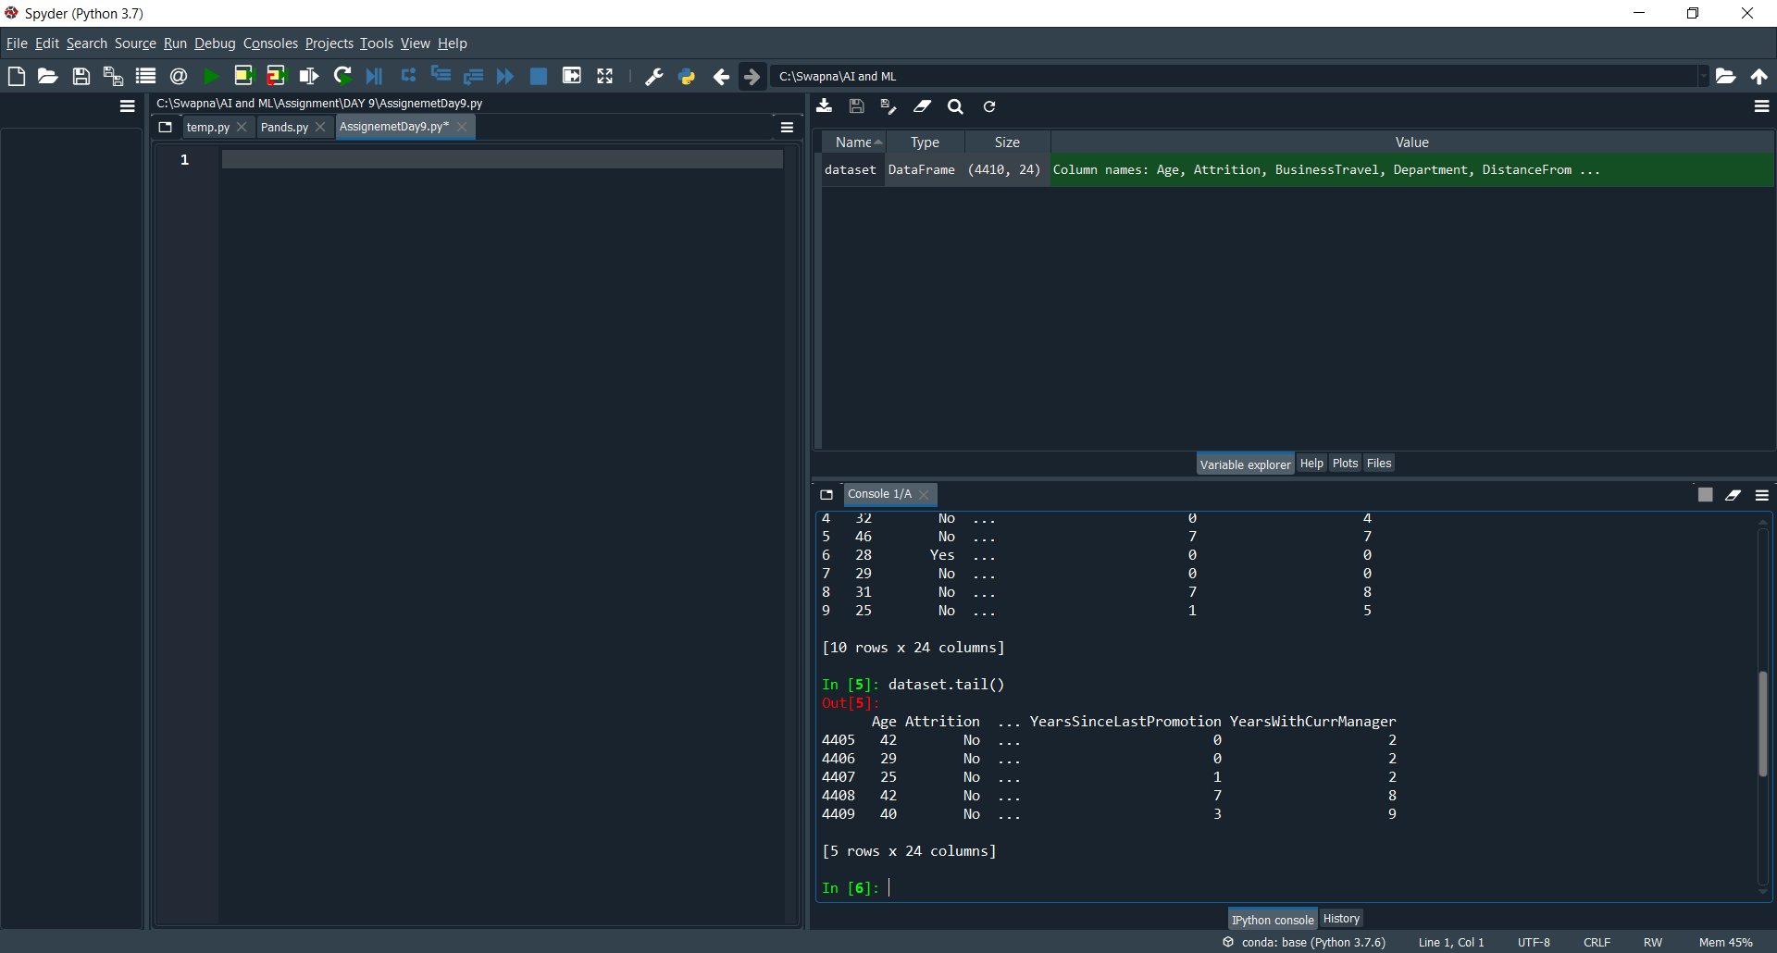

dataset.tail()

it will display prints the last 5 records

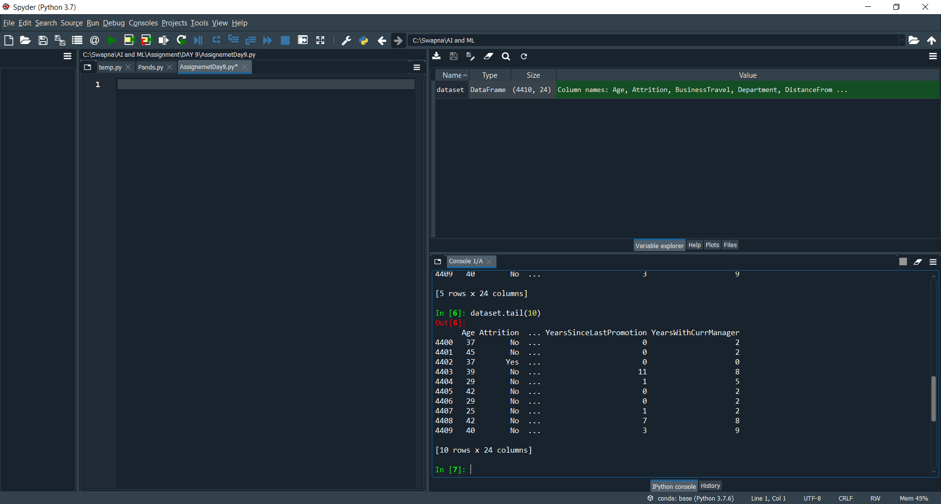

dataset.tail(10)

it will print the last 10 records

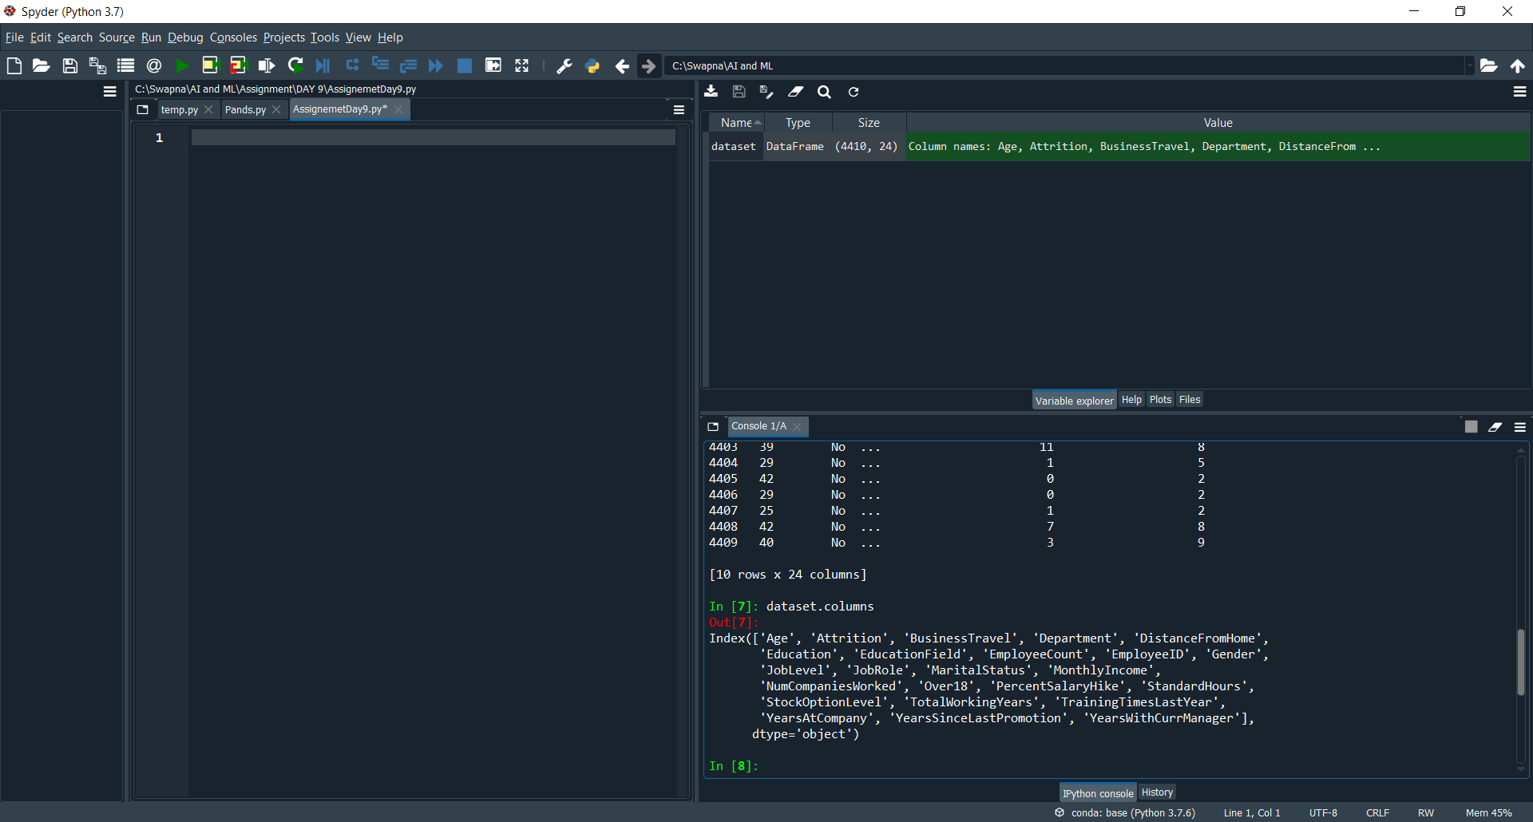

dataset.columns col in the sheet

we can identify the no of columns in the data.

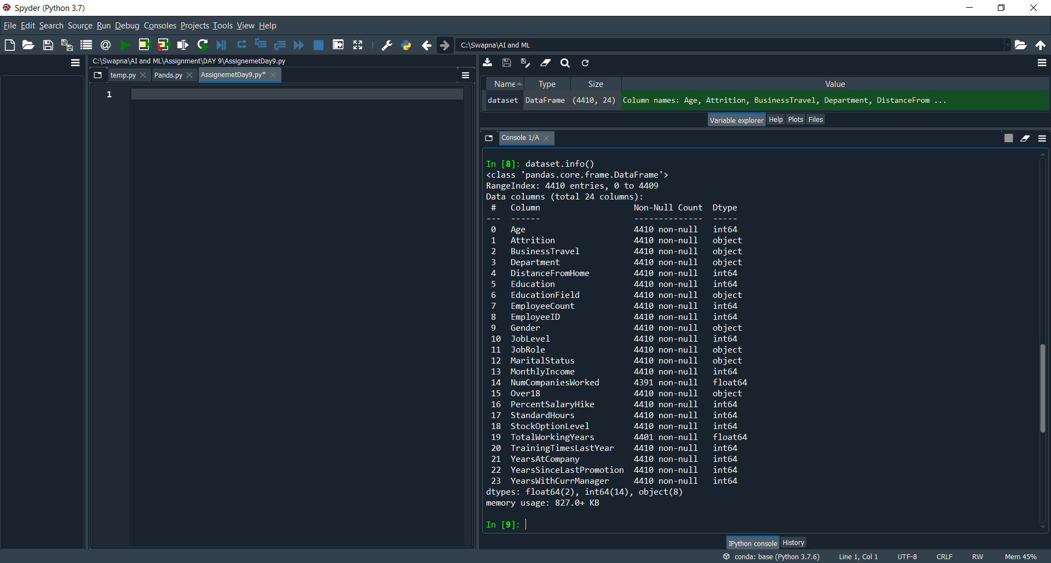

dataset.info() complete description (information about the sheet)

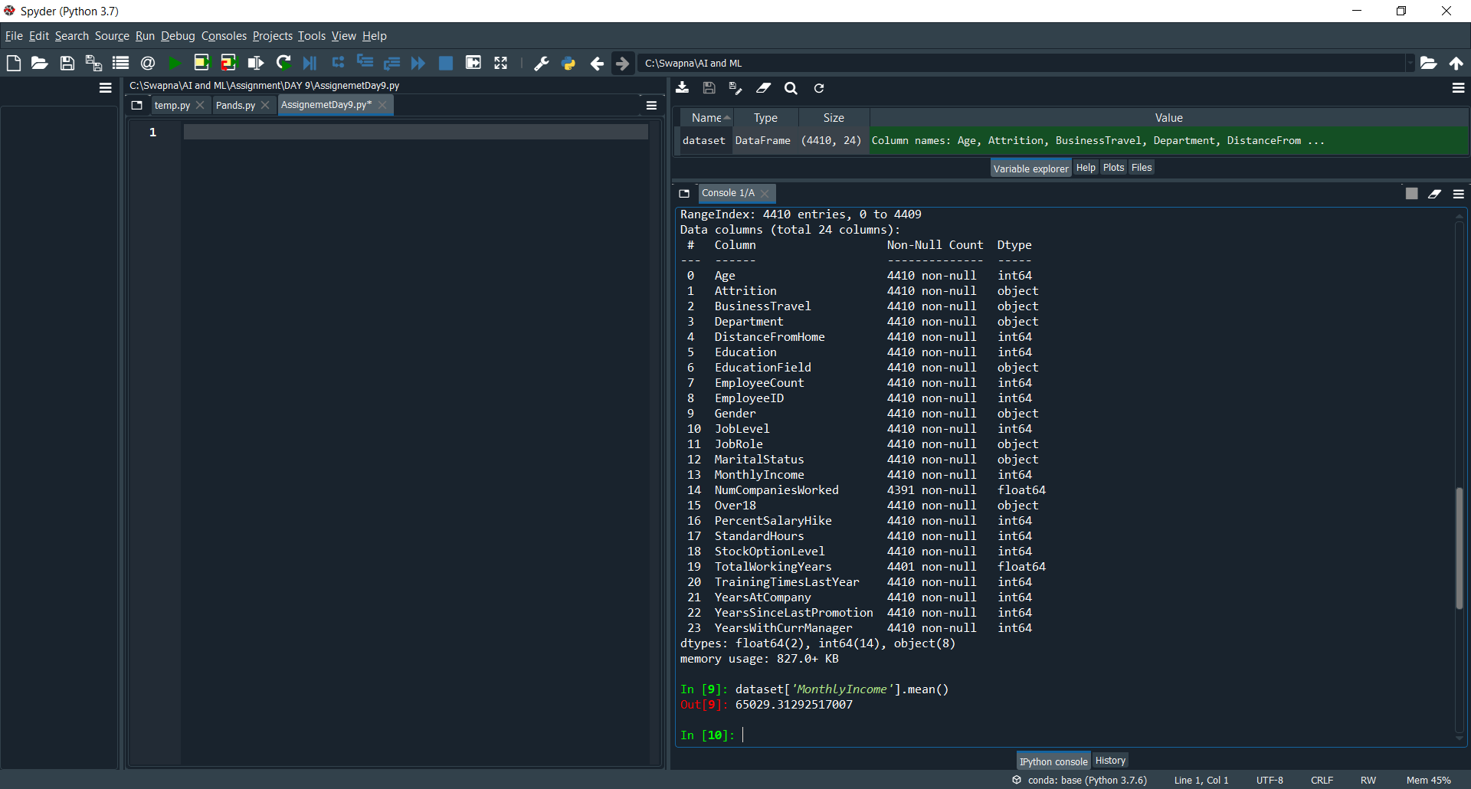

dataset[MonthlyIncome].mean() to find the AVG

to analyze the databBy this we can get the average salary for the employees to take the decision.

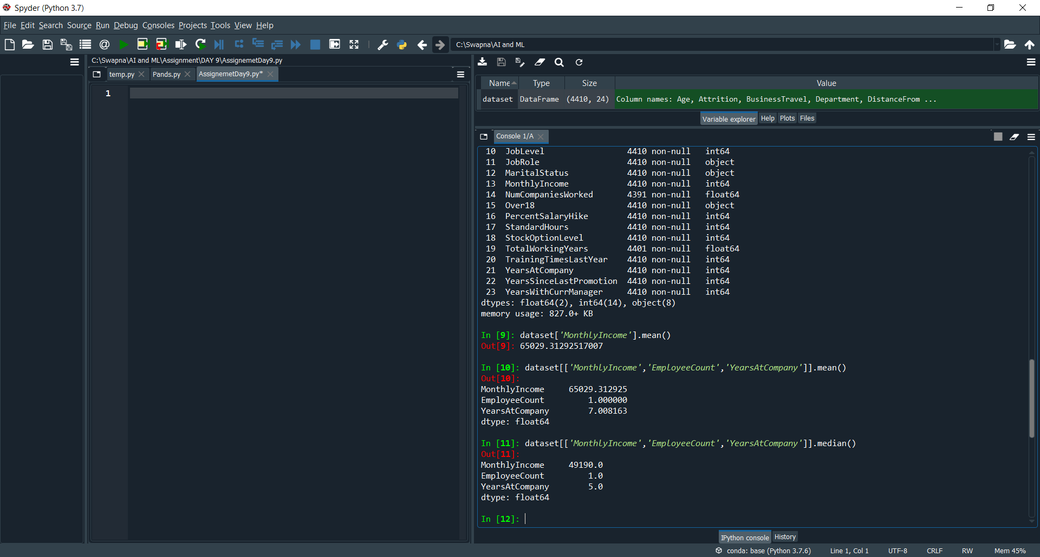

dataset[['MonthlyIncome','EmployeeCount','YearsAtCompany']].median()

To check the MIDDLE VALUES we can use this . median()

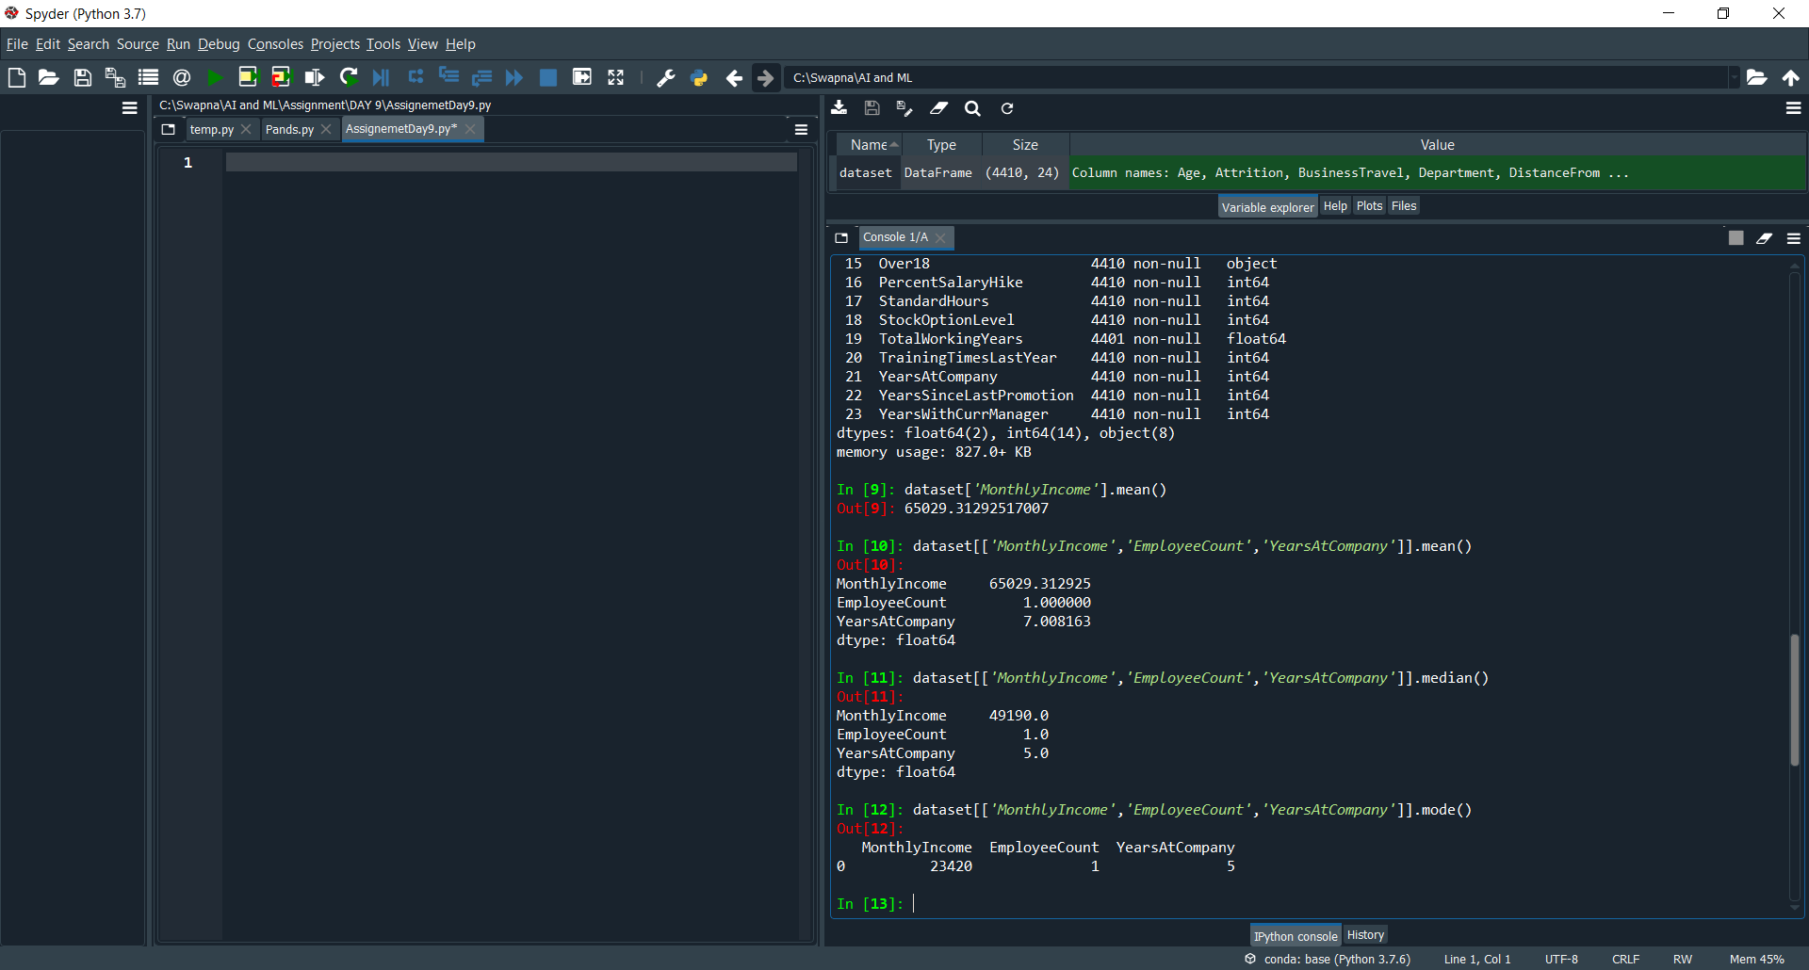

dataset[['MonthlyIncome','EmployeeCount','YearsAtCompany']].mode()

to check the MOST FRQUENTLY ACCOURED.

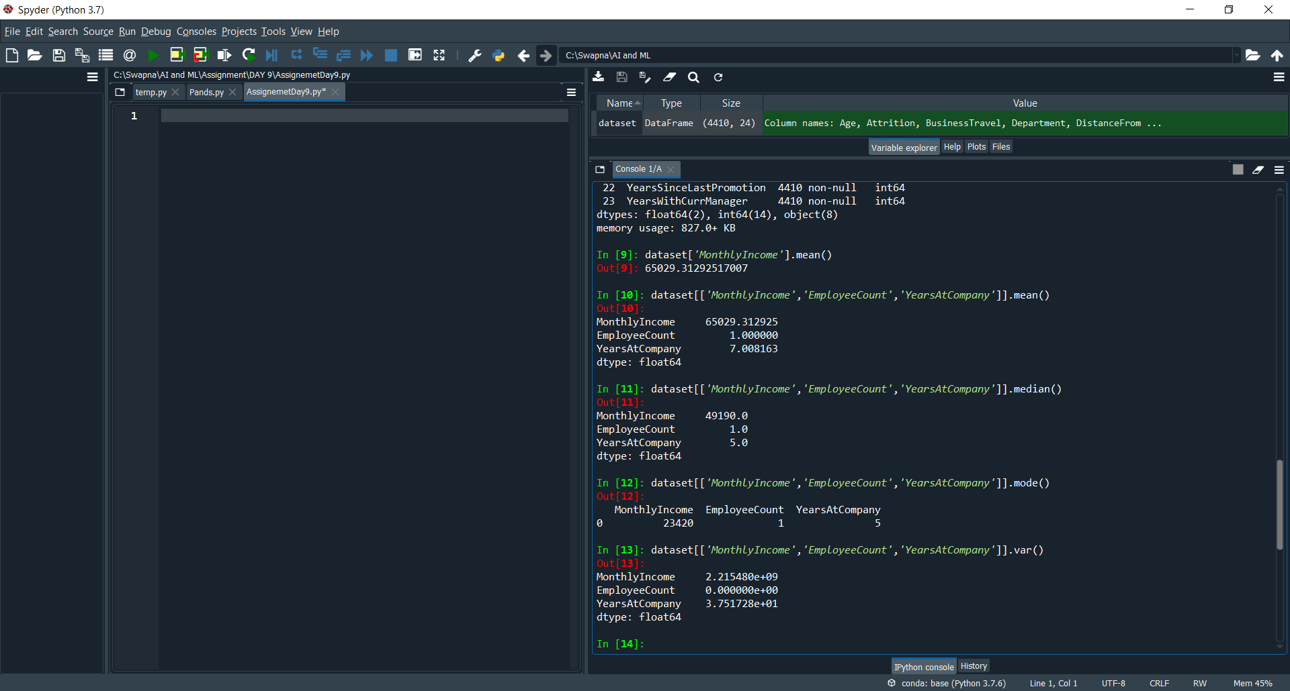

dataset[['MonthlyIncome','EmployeeCount','YearsAtCompany']].var()

HOW MUCH VARIATION IN THE DATA.

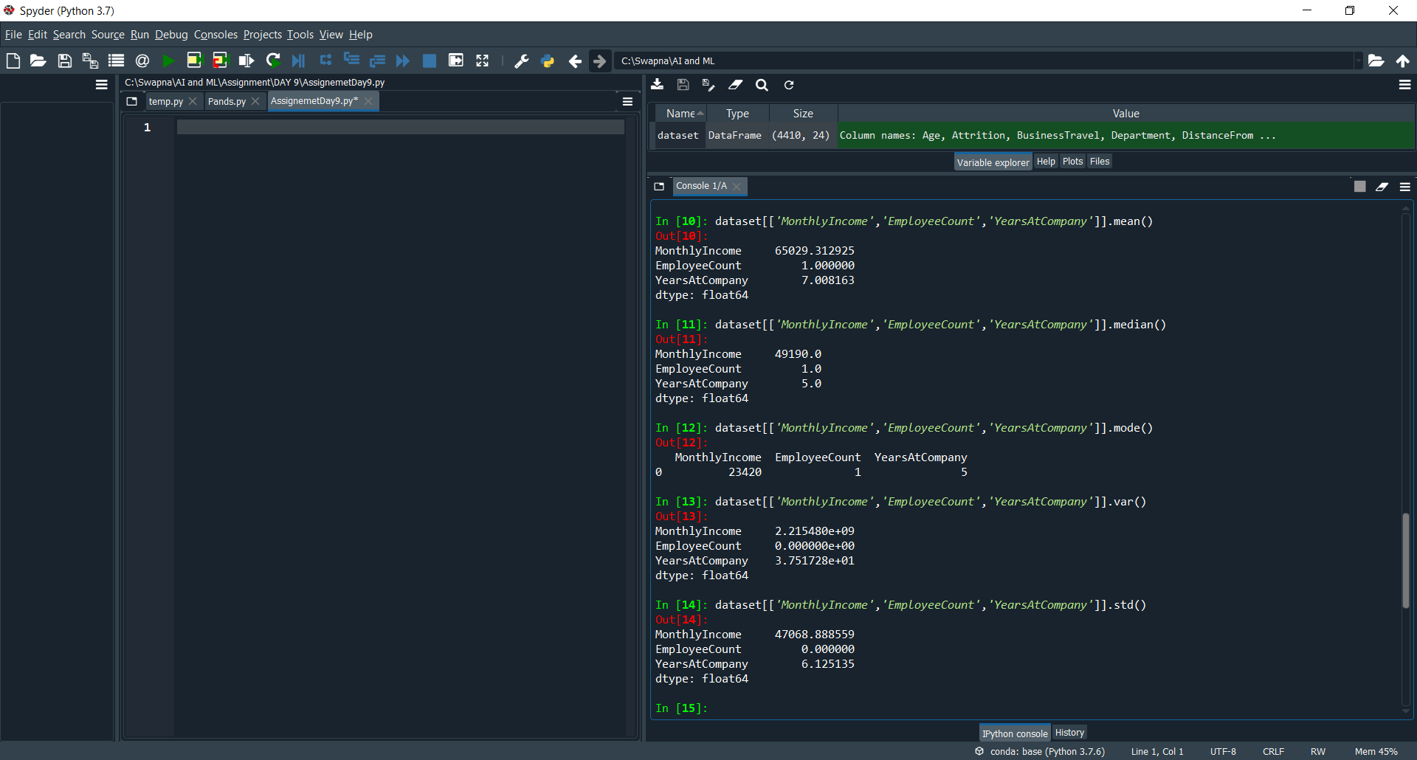

dataset[['MonthlyIncome','EmployeeCount','YearsAtCompany']].std()

By this we can analyze the Consistency of the data.

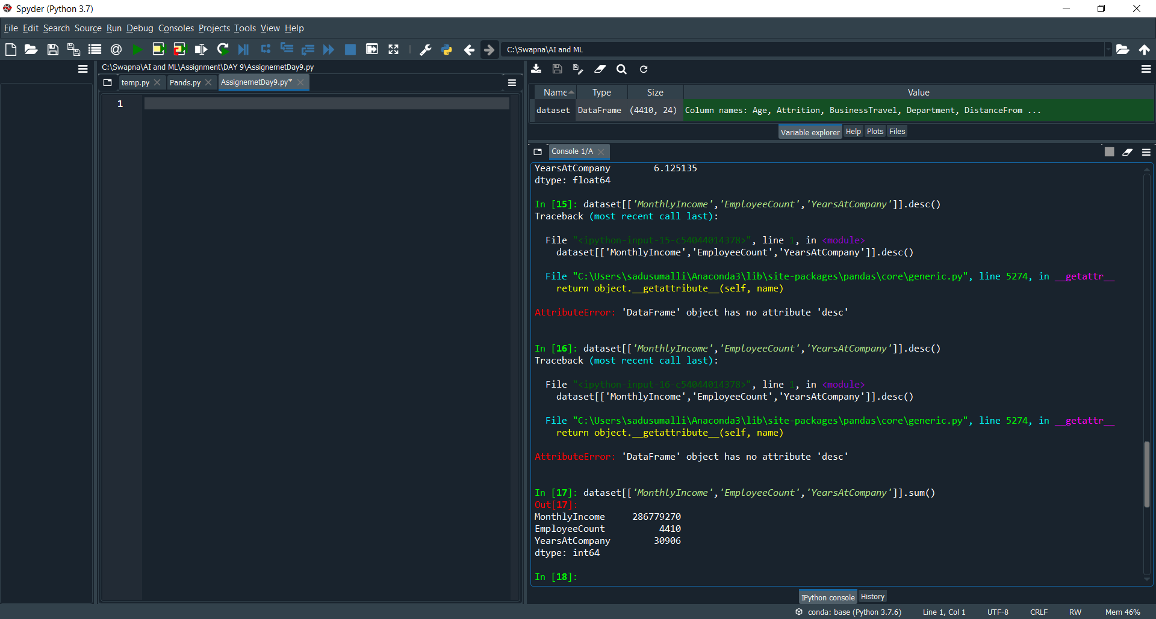

dataset[['MonthlyIncome','EmployeeCount','YearsAtCompany']].sum()

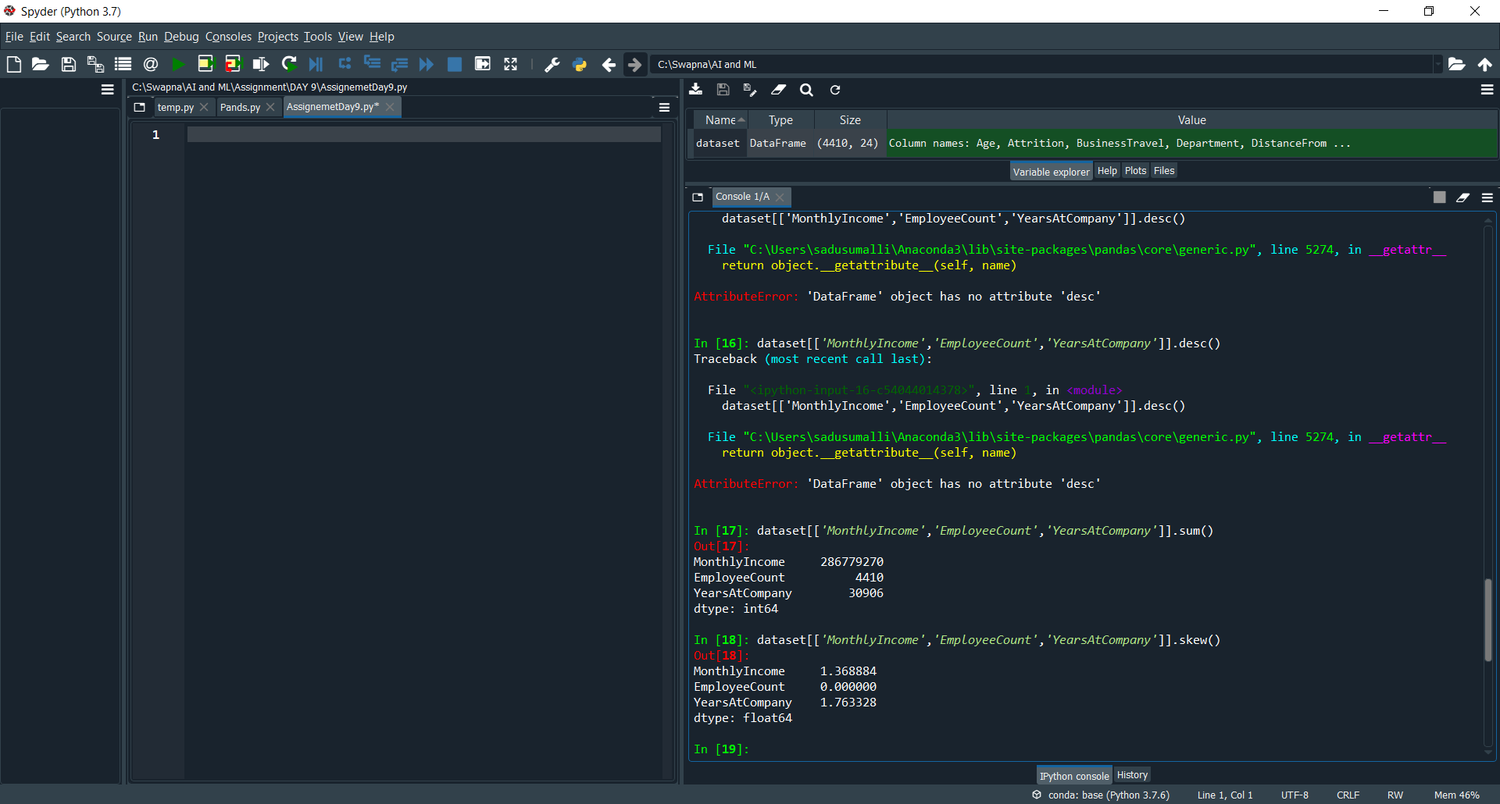

dataset[['MonthlyIncome','EmployeeCount','YearsAtCompany']].skew()

to get the Symmetric data.

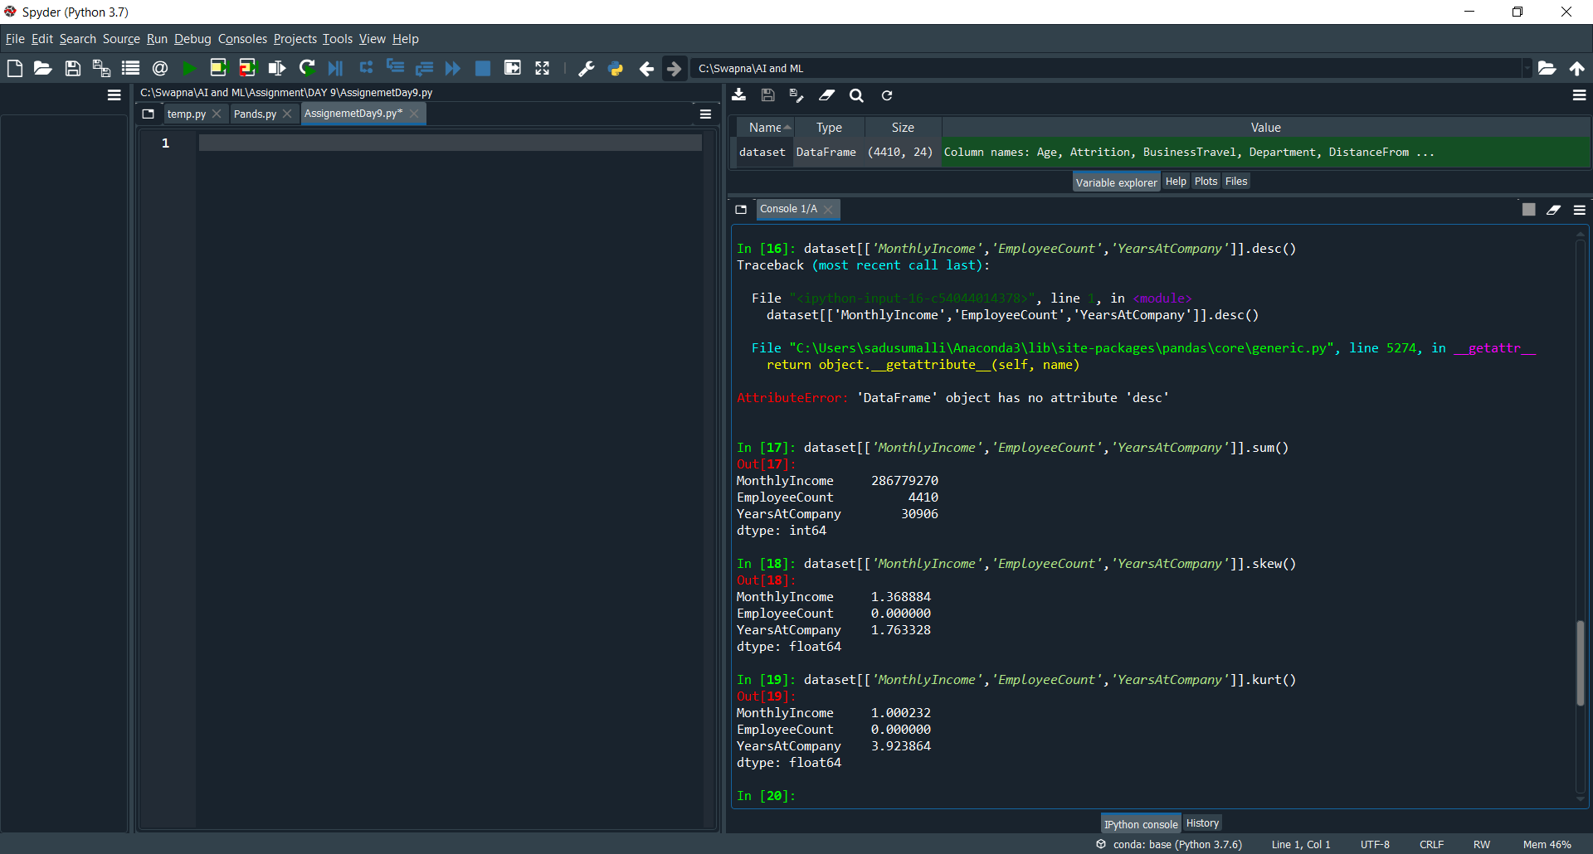

dataset[['MonthlyIncome','EmployeeCount','YearsAtCompany']].kurt()

to identify the Peakness of the data.

Here **kurt** values **POSITIVE** so it is a **leptokurtic.**

So we got how data is distributed.

## The value of the

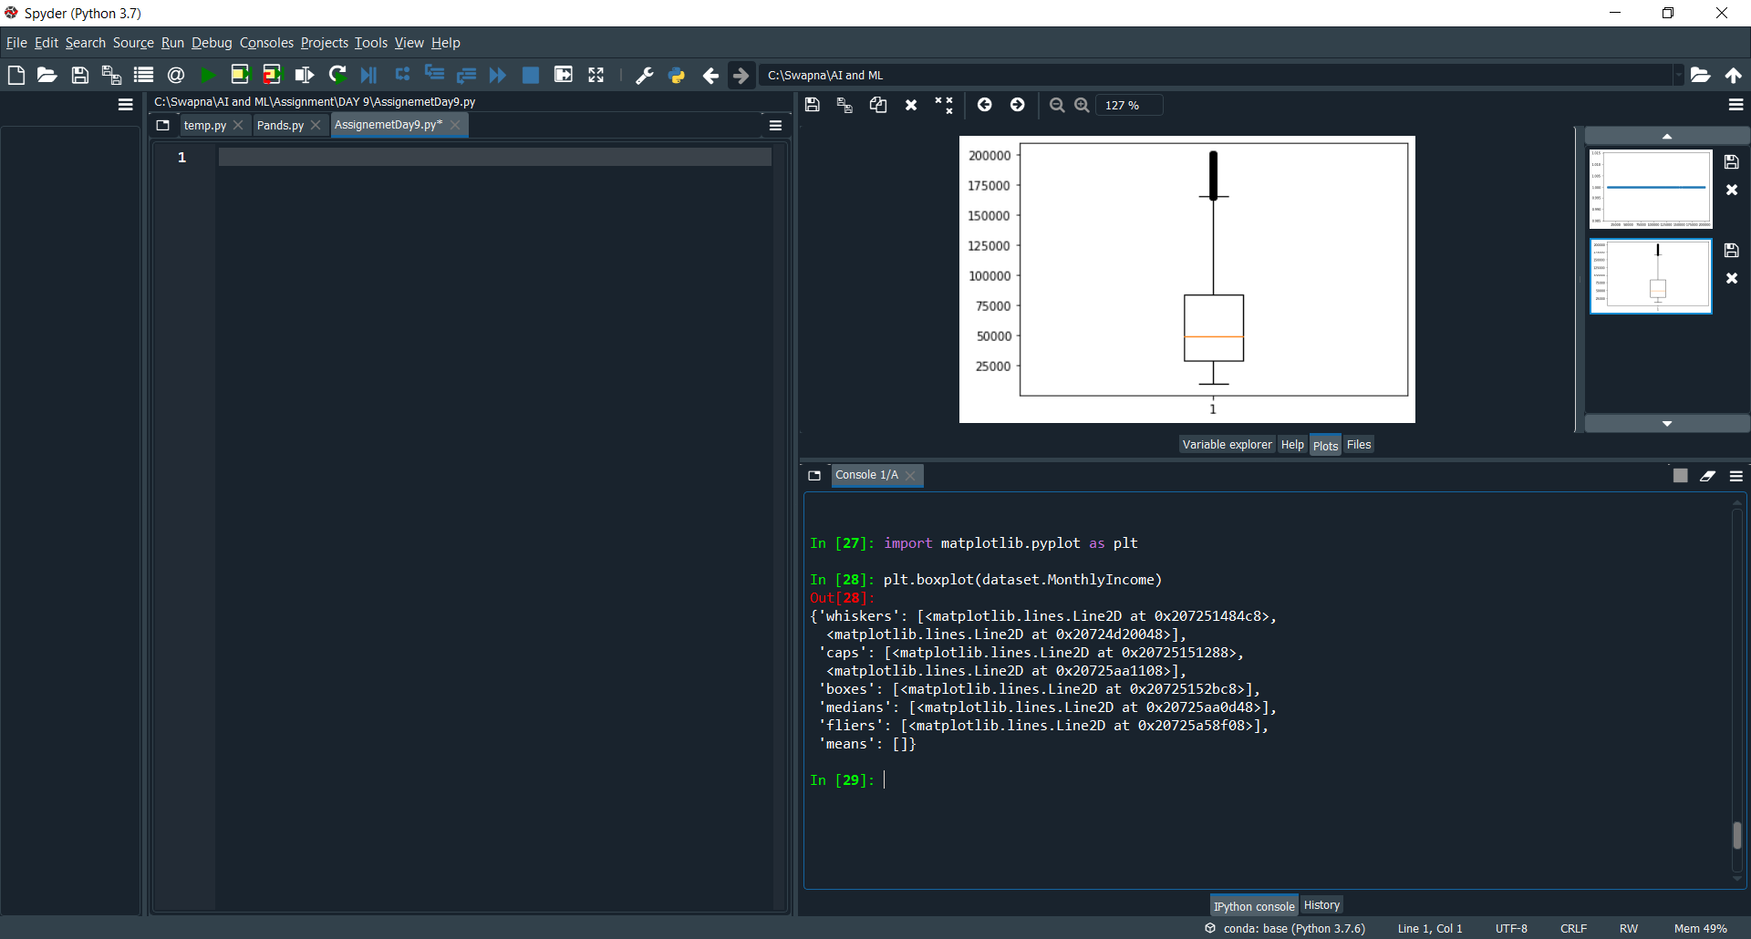

plt.boxplot(dataset.MonthlyIncome) it will give the graph

we can identify the Outlier.the bubbles indicates the Outlier

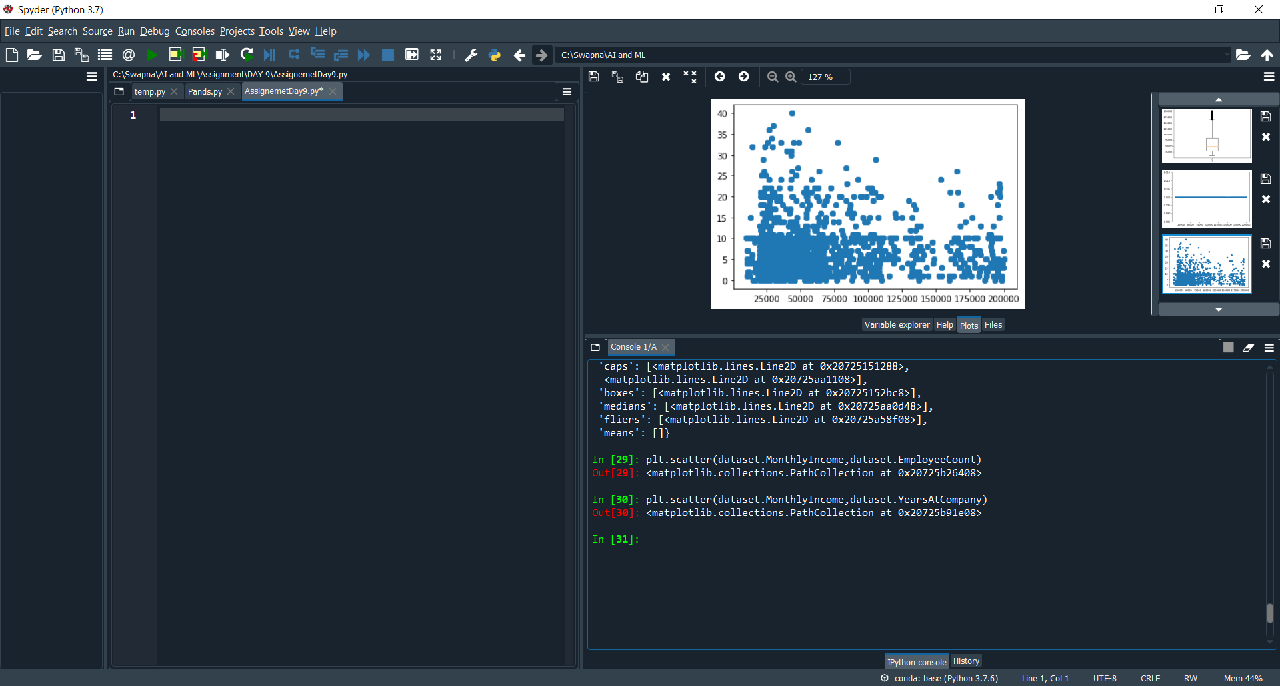

plt.scatter(dataset.MonthlyIncome,dataset.YearsAtCompany)

by using the scatter we can identify the Outlier in dataset.

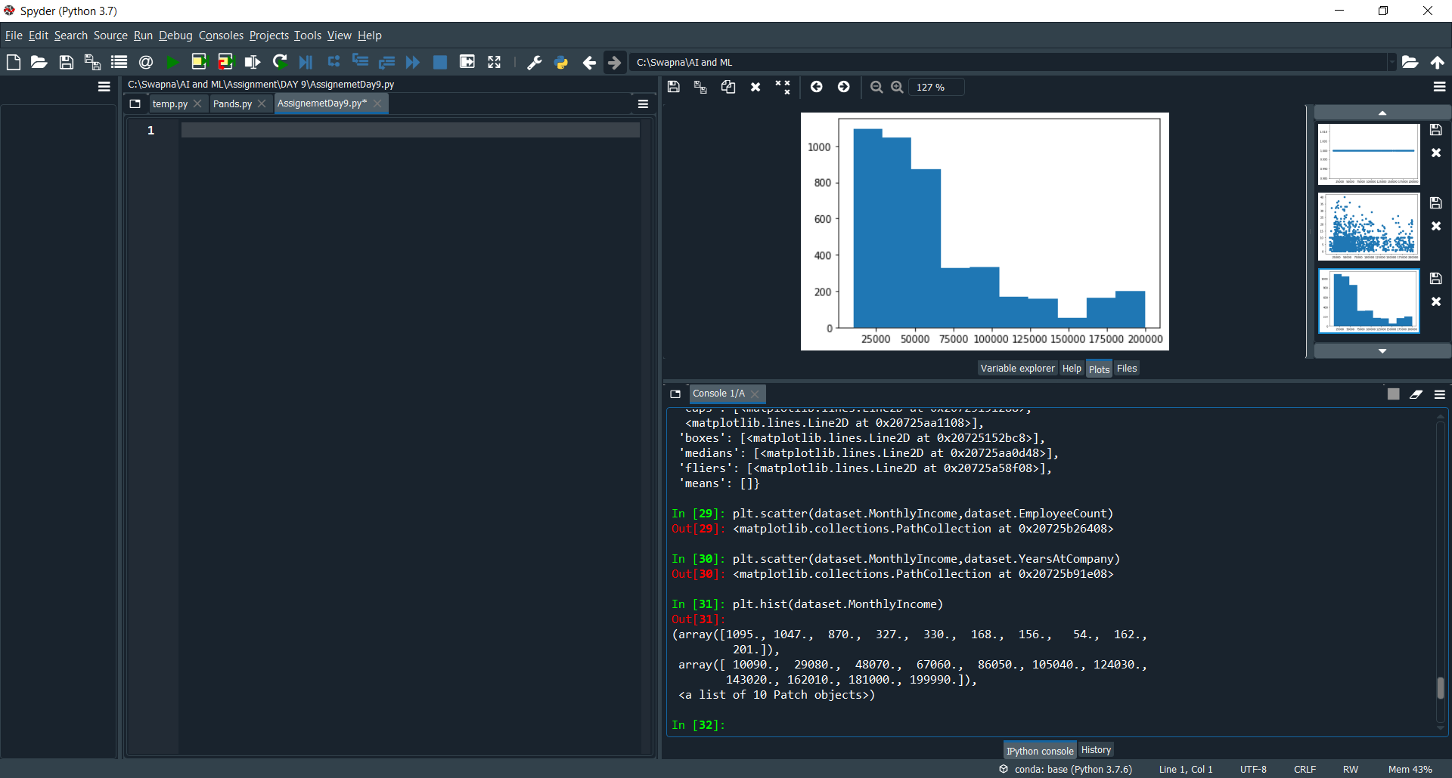

plt.hist(dataset.MonthlyIncome)

Buy using hist method we can get the skewness in the form of pictorial.

So by the diagram we can see the skewness Is left side, so It means it is a **positive skewness**.